A000-MEX-Olmec-Mask-Jade-1100 BCE

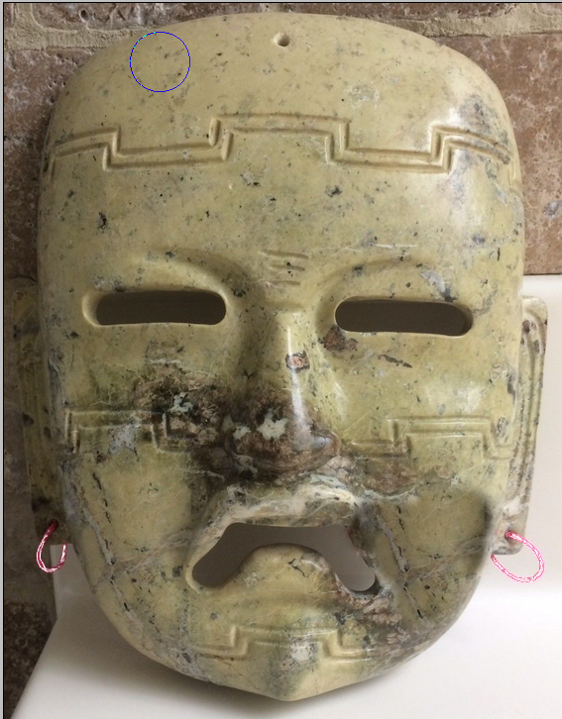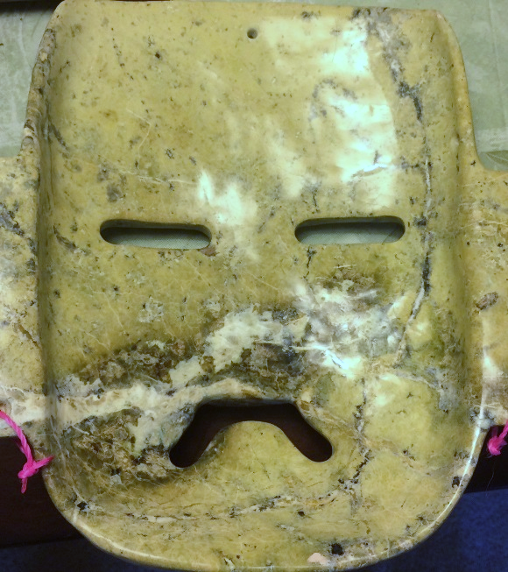

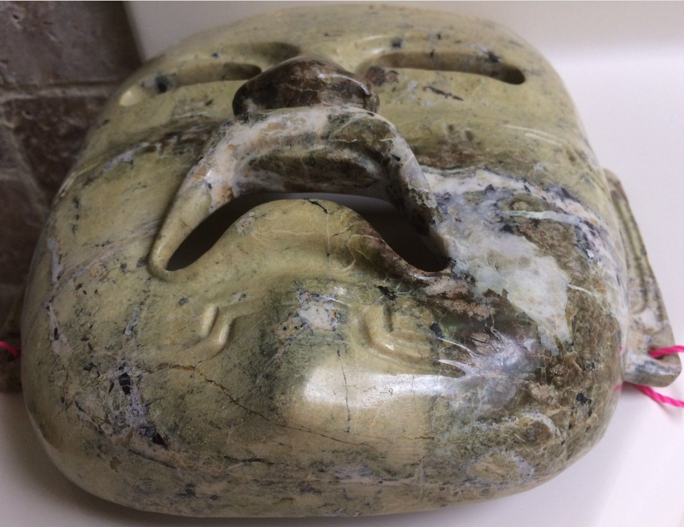

**Case No.: 10**

**Accession No.**

**Formal Label:**

**Display Description:**

**LC Classification:**

**Date or Time Horizon:**

**Geographical Area:**

**Map:**

**GPS coordinates:**

**Cultural Affiliation:**

**Media:**

**Dimensions:**

**Weight:**

**Condition:**

**Provenance:**

**Discussion:**

**References:**